Final Project Report

My Clothing Application

Subject: IICT

Clothing brand: Style Sphere

By:

Ahmad Habib 23I-0011

Umer Naseer 23I-0663

Section: CS-B

To:

Ma’am Qurrat Ul Ain

Content Page

1. Introduction to our brand
2. Screenshot of each Page and its Explanation
3. Conclusion

**Introduction**

Style Sphere is not just a brand; it's a celebration of personal style and uniqueness. We believe that everyone should have the freedom to express themselves through fashion. Our collections are designed to cater to diverse tastes, offering a mix of trendy and comfortable styles. Quality, innovation, and inclusivity are at the heart of what we do. At Style Sphere, we want to empower individuals to confidently embrace their identity and make a statement with their wardrobe. Welcome to a world where fashion is a form of self-expression, and every outfit tells a unique story.

In this report, we will go through each of our webpage and will get to know what each page represents.

**Website**

**NOTE: All the screenshots does not fully cover the webpage**

**Navigation Bar**

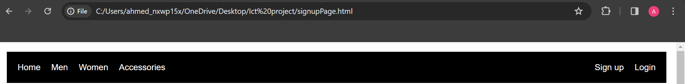

This is the navigation bar; it contains accessibility to all the categories and webpages on the website. This bar is on every webpage.

**Footer**



This is the footer of our website. It is also present on every page of our website. It contains contact details and links to our social media pages.

**Login page**

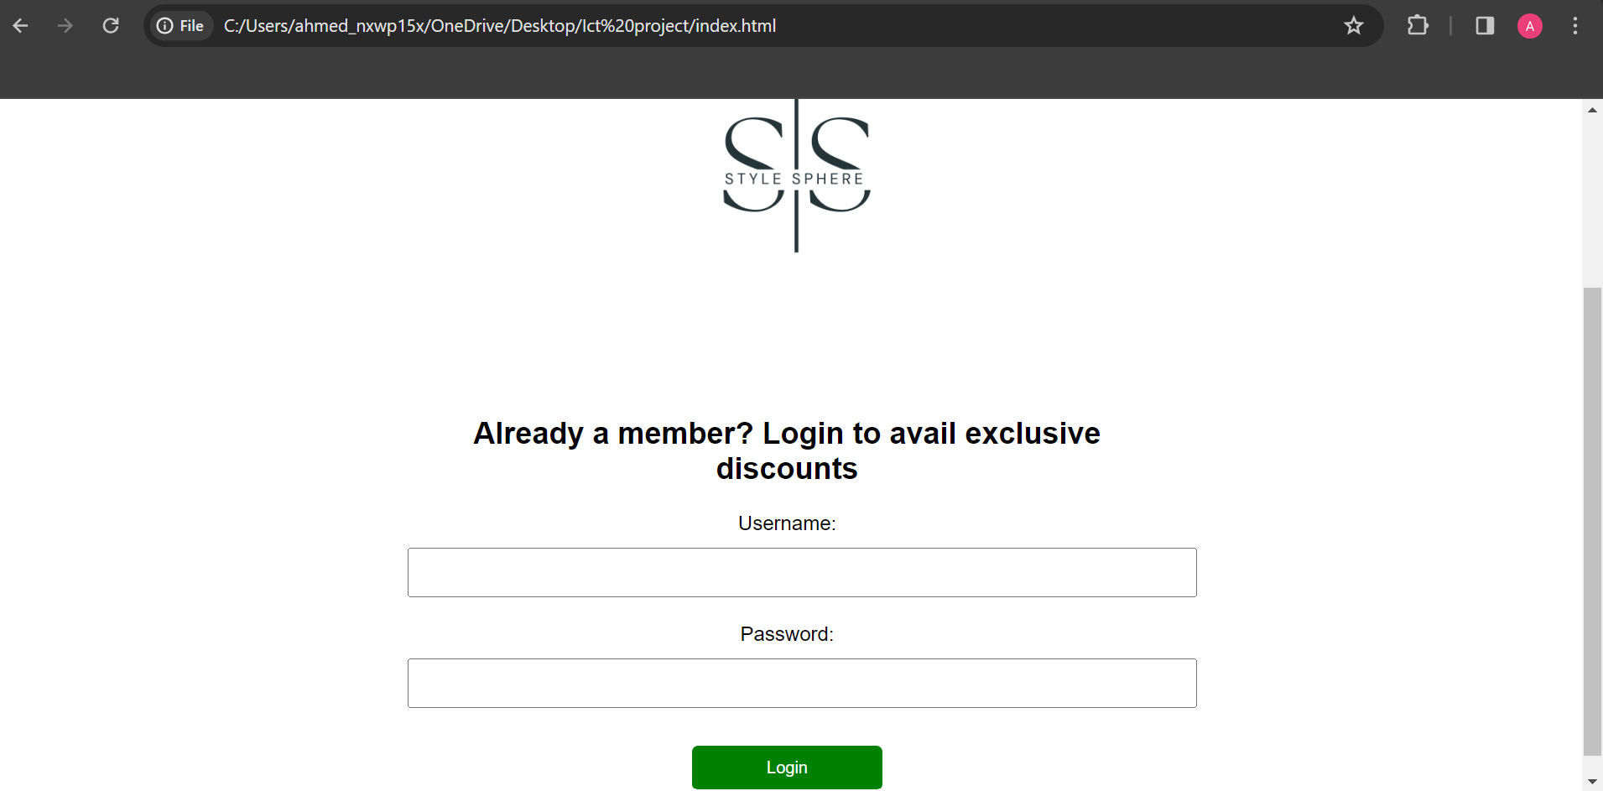

This is the login page; it contains a form for the user to fill. The login button contains the link to home page of the website

**Signup page**

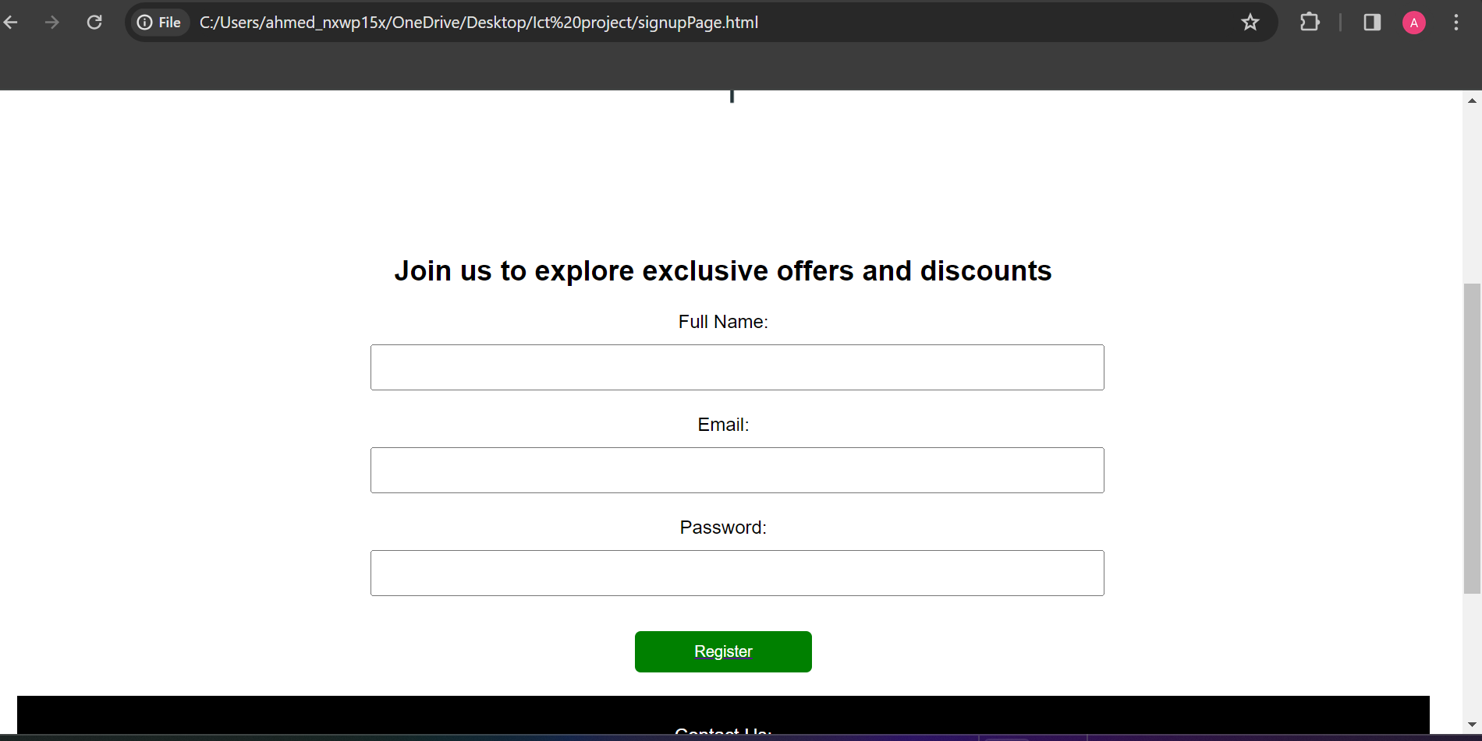

This is the signup page. User can create his account here and then this button links to the login page. The user is required to login then.

**Home page**

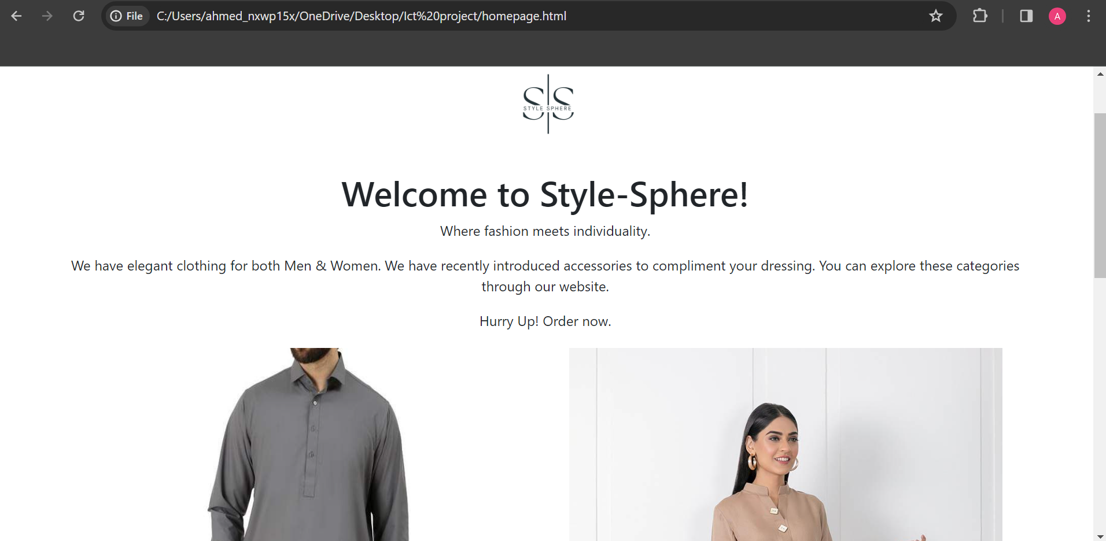

This is the home page of the website. It is an introduction to our website, and we have displayed two pictures of the products that generally represents what we sell.

**Men’s Page**

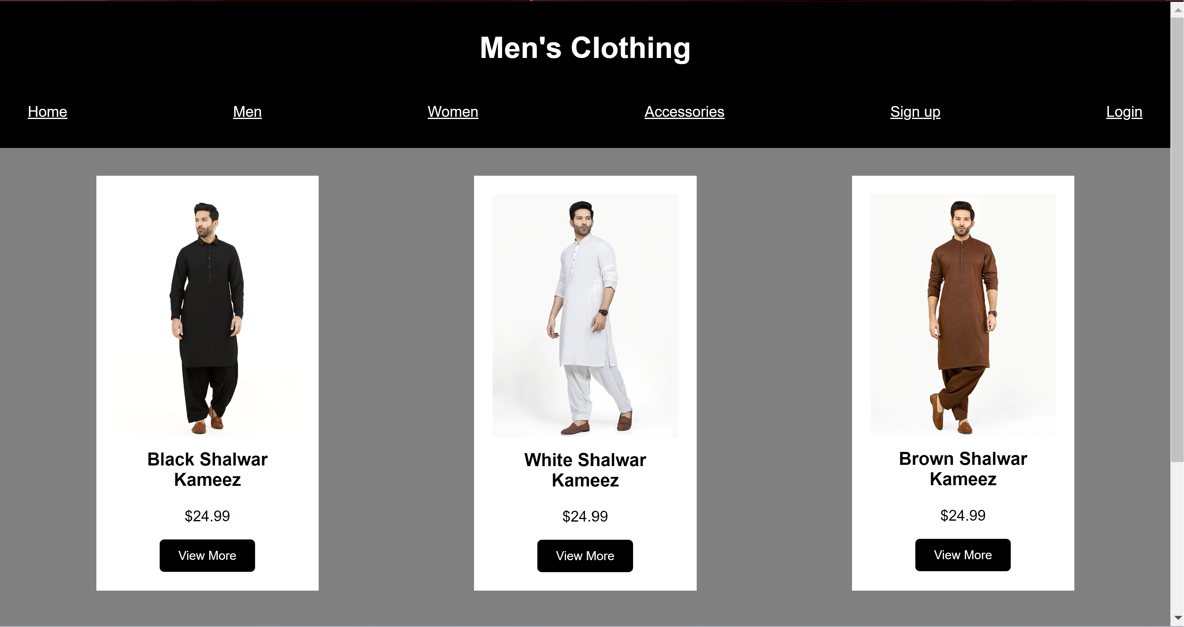

This is the page for the men’s category. It showcases the products available under the category and allows you to click on the product you are interested in by pressing the view more button to see further details about the product and purchase it.

**View More Functionality**

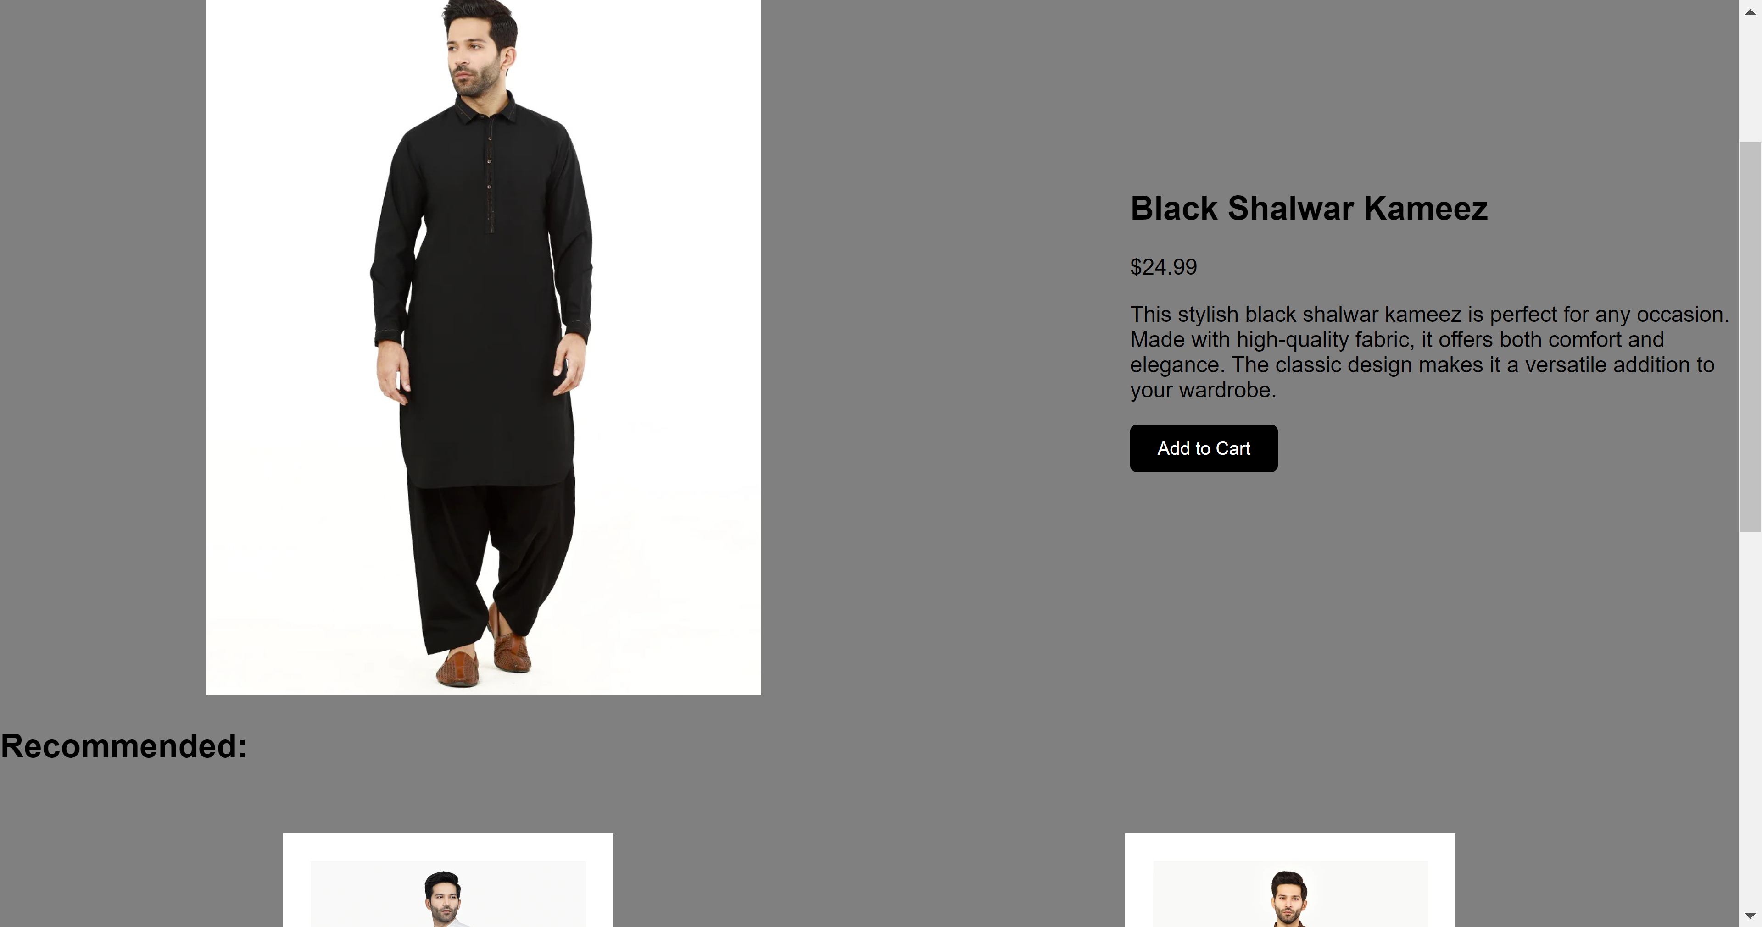

After clicking the view more button, it presents this page where detail about the product is provided. On this page you are given the option to add the product to your cart which will take you to the shopping cart page where you can finally proceed to checkout. On this page recommendations are also given based on the selected product.

**Shopping Cart Page**

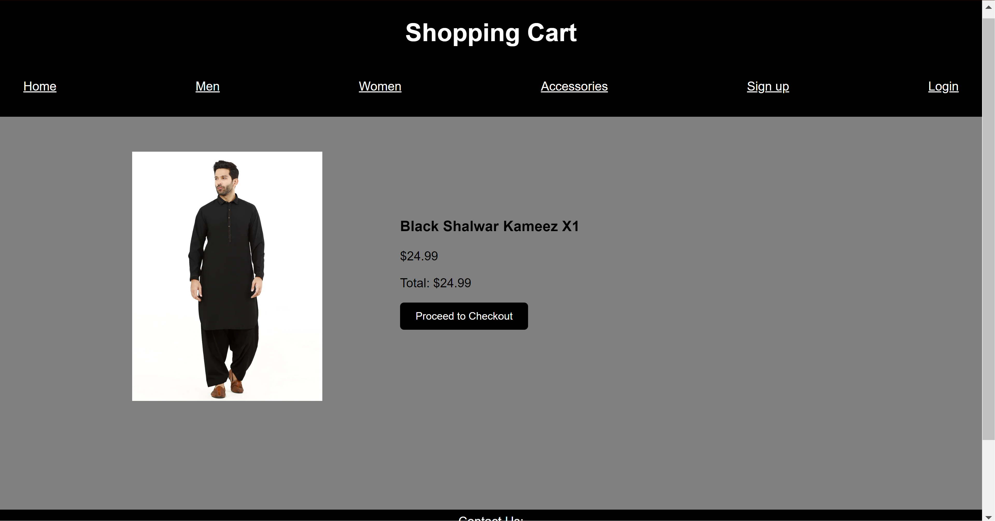

This is the shopping cart page which appears after you’ve added a product to the shopping cart. It tells you the product you are buying along with a picture of it and the total price. From here you can proceed to checkout where you can enter card information and complete transaction.

**Recommendation Functionality**

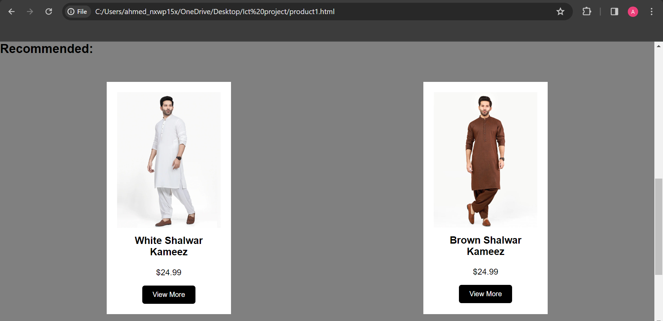

This is the recommendation of more products functionality; it is implemented in all three category pages to enhance user experience.

**The described functionalities are available for all the products not just the one showcased in the pictures.**

**Women’s Page**

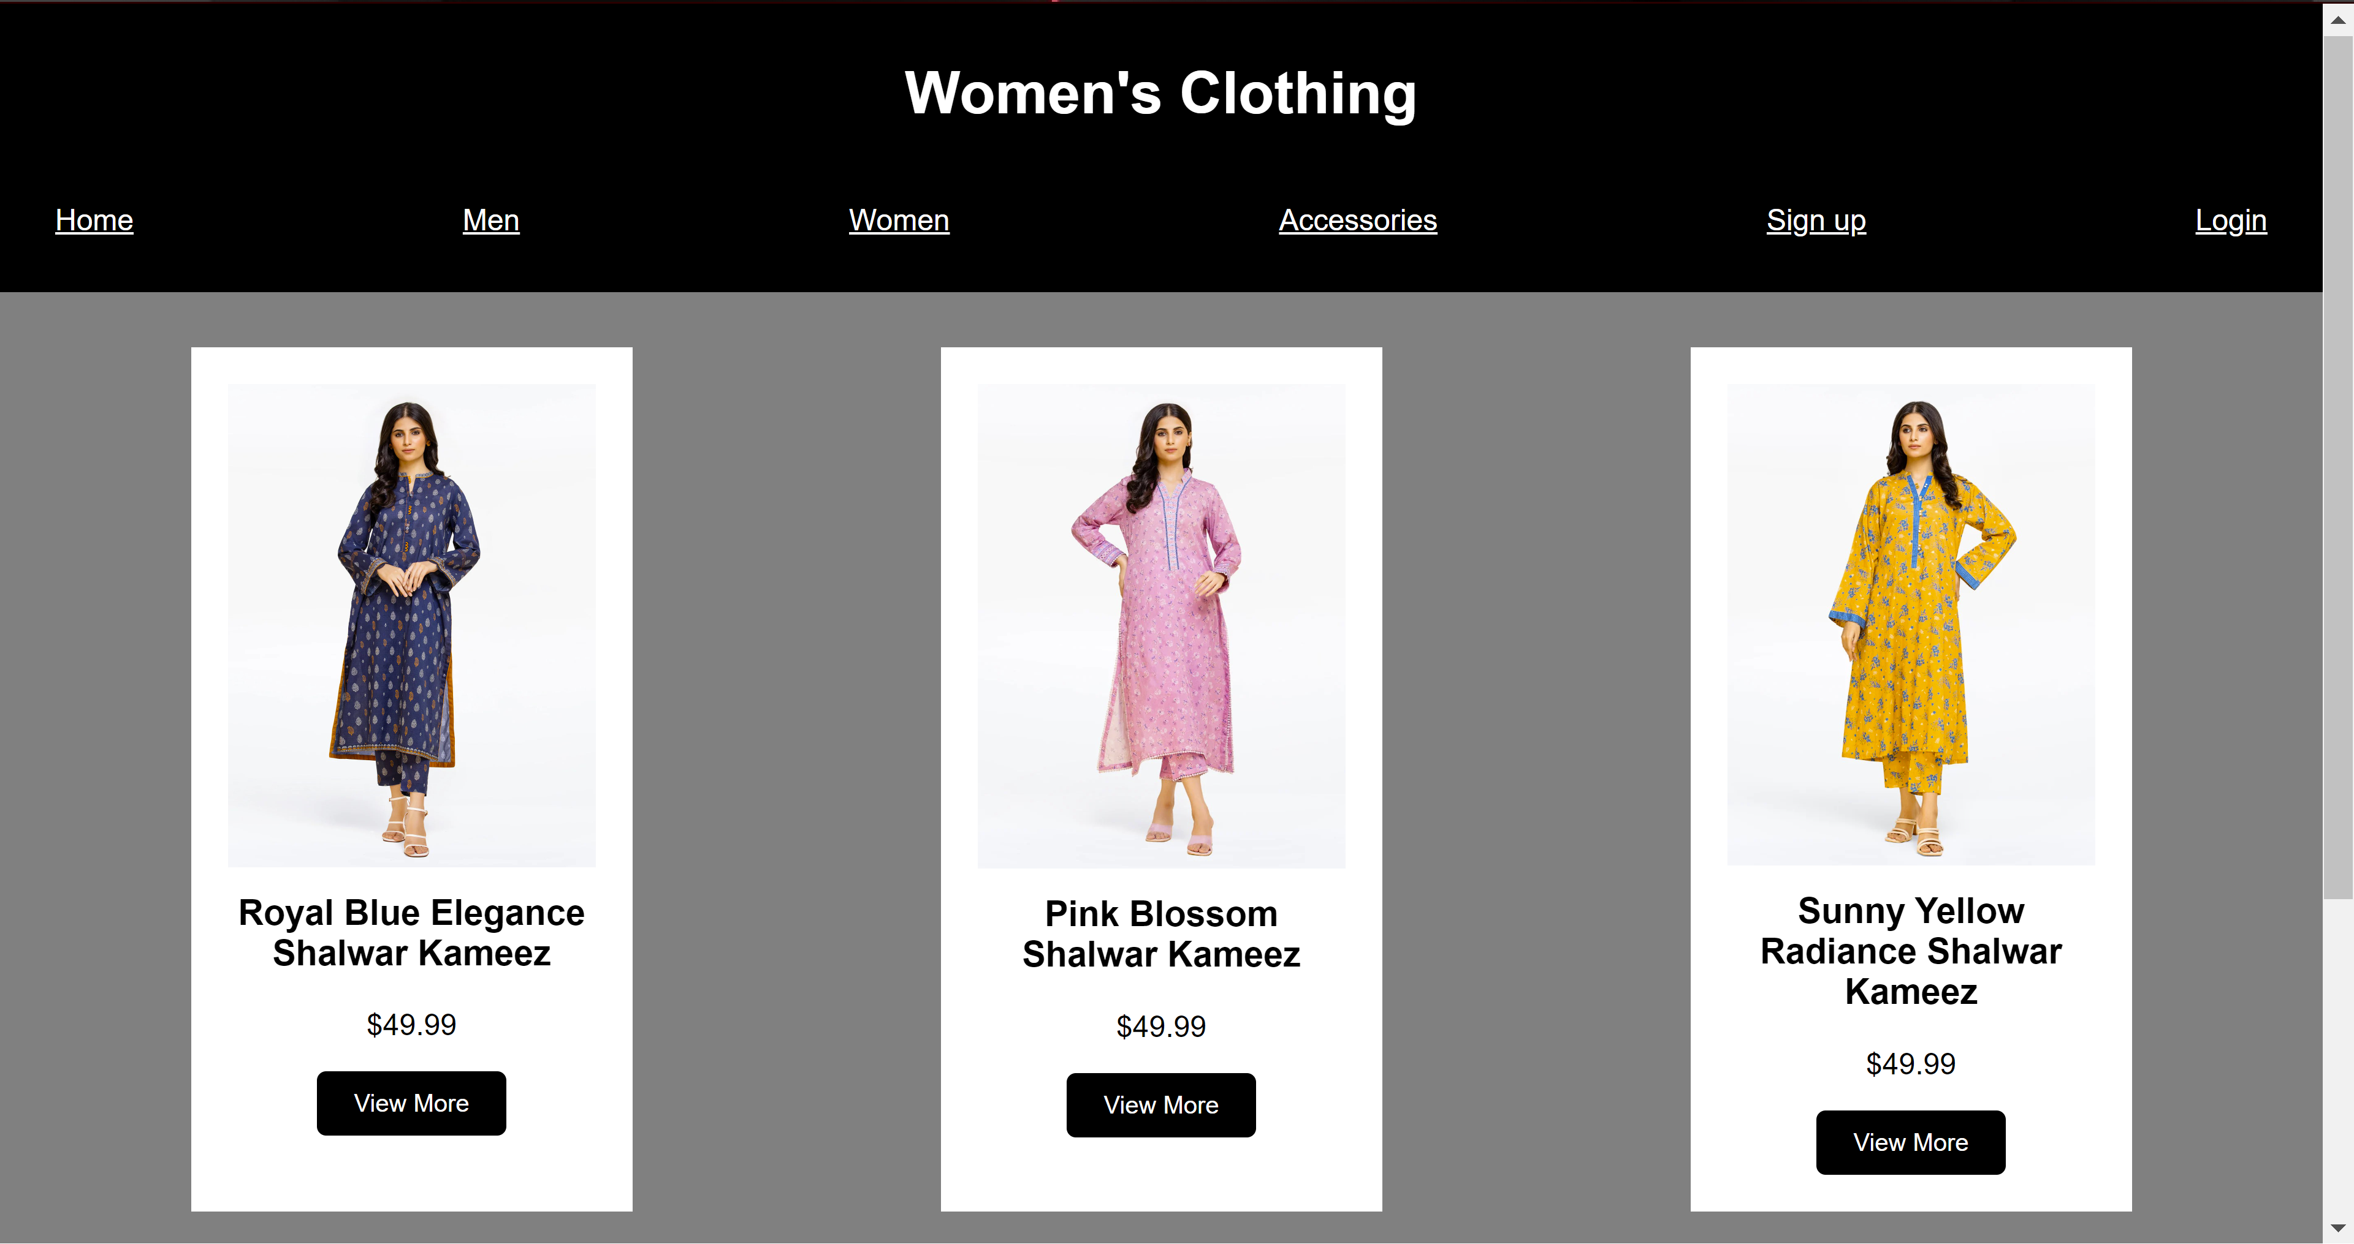

**Accessories Page**

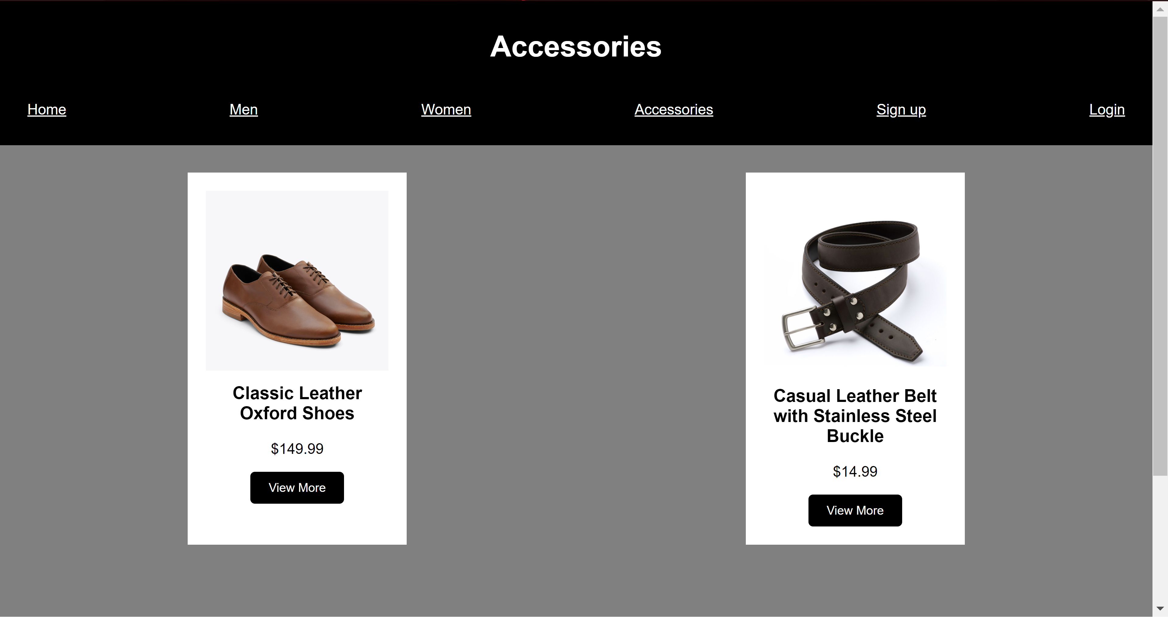

Both the women’s category and the accessories category have similar pages to the described men category, and they share the same functionalities for each of their products.

**Payment Page**

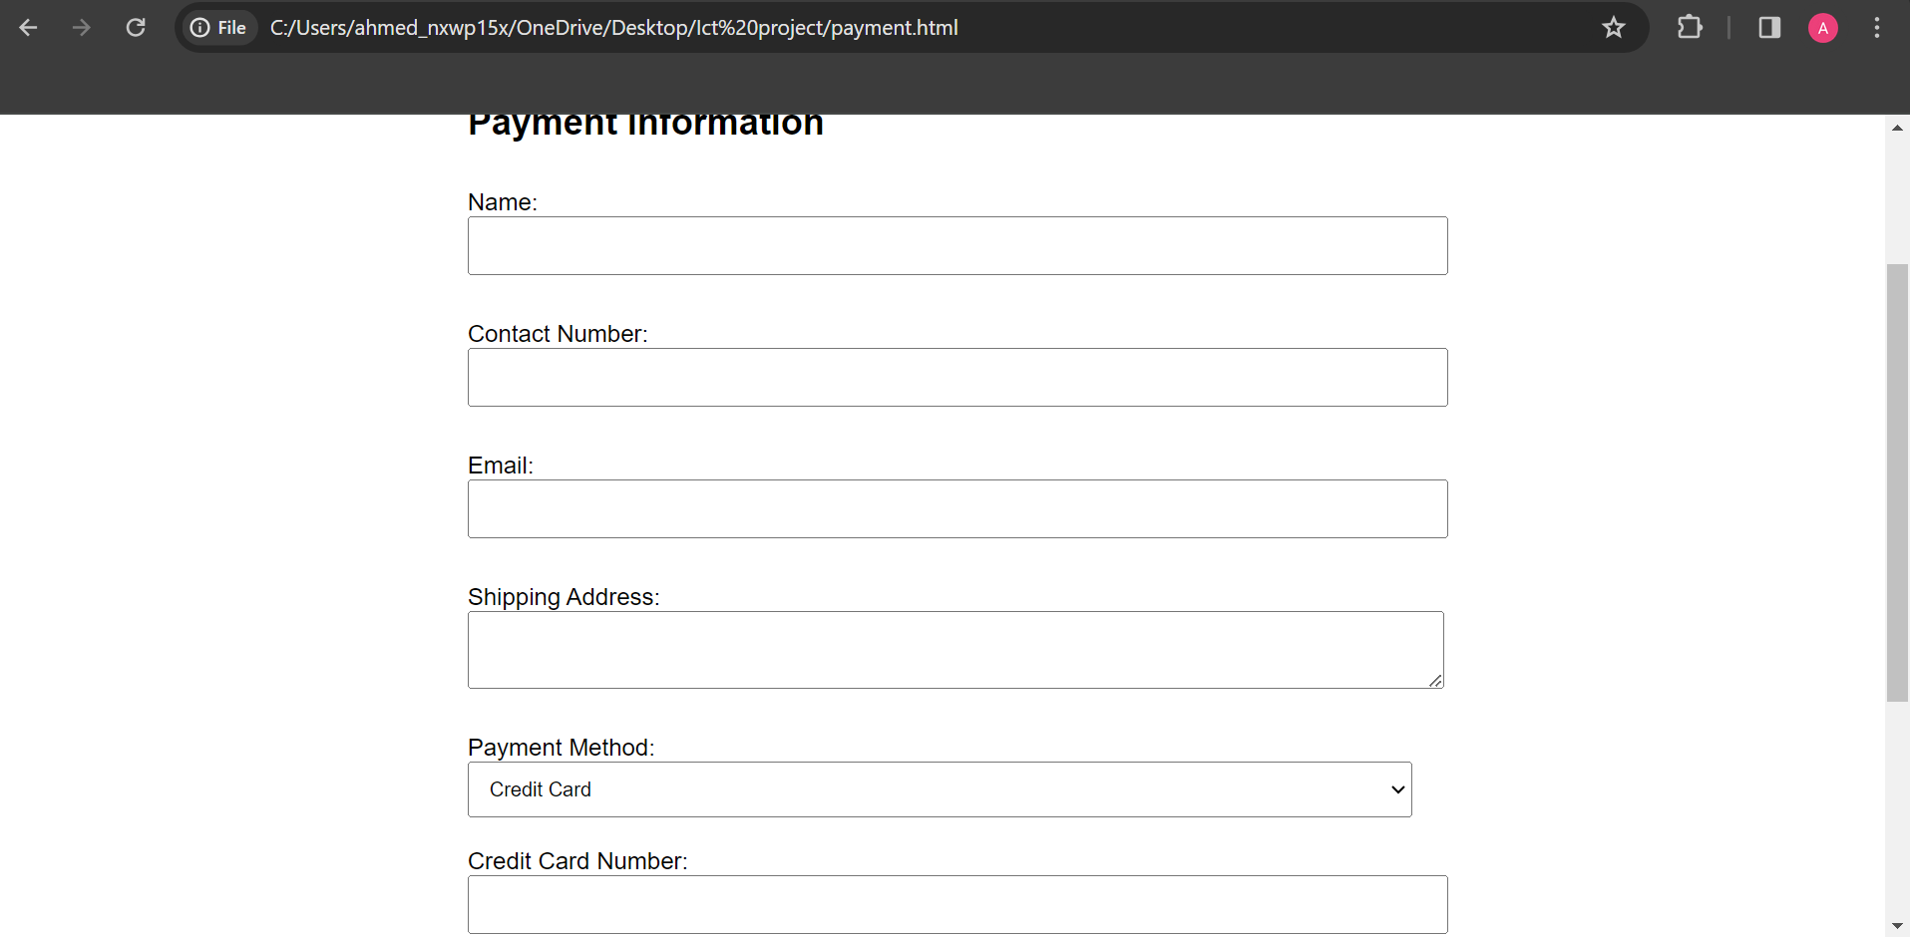

This page contains the payment details of the user. He can either choose credit card or cash on delivery. On choosing credit card, he must fill the required details of the card. The place order button links back to the home page.

**Conclusion**

As we conclude, we invite you to join the Style Sphere community and embark on a fashion journey that celebrates your individuality. By choosing Style Sphere, you're not just buying clothes; you're investing in a brand that values your freedom to express yourself through fashion. As we explored each part of our website, we looked at what each section is for. The homepage is easy to use and helps you move around the site easily. The signup and login pages are made to be simple and friendly. The payment page is easy too, showing how much, we care about making your shopping experience nice and easy. We're really happy for you to explore and make Style Sphere a cool part of your fashion adventure.